***Introduction to Artificial Intelligence Assignment 1 2023***

By: Rotem Babani & Carmela Plishtayeb

To run our program, in your respective IDE , add “Input.txt” as an argument.  
This file is the input for our Asasignment.

**\*If you are using Eclipse make sure that the Input.txt file is inside the Project folder\***

**Input:**

The input to the program is a file that includes a Maze in the following format. The first line of the file defines the size of the maze. For example, 8 means an 8x8 square. Next, come rows in the number described by the size and each row has numbers describing the Maze in that row. The number 0 is a white square and 1 is a black one. For example, the above figure has the following 3 first lines in its file:

10

0 0 0 0 0 0 0 0 0 0

0 0 0 1 0 0 0 1 0 0

0 0 1 0 0 0 1 0 0 0

**Output:**

The output will be saved in the “output.txt” file following this format:

Greedy (search 17 nodes; path length 9): (1,1),(1,2),(1,3),(2,3)...(n,n)

UCS (search 22 nodes; path length 19): (1,1)...(n,n)

Astar (search 32 nodes; path length 8): (1,1)...(n,n)

**Examples:**

1. **Maze is in the size of 10*10:**

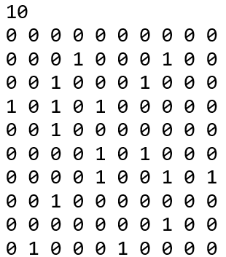

**The output:**

1. **Maze is in the size of 20*20:**

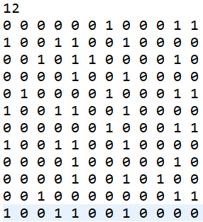

**The output:**

**Astar** (search 530 nodes; path length23):

(1,1)(1,2)(2,2)(3,2)(4,2)(4,3)(5,3)(6,3)(7,3)(7,4)(7,5)(7,6)(8,6)(8,7)(9,7)

(10,7)(11,7)(11,8)(11,9)(11,10)(12,10)(12,11)(12,12)

**UCS** (search 87009 nodes; path length: 23):

(1,1)(1,2)(2,2)(3,2)(4,2)(4,3)(5,3)(5,4)(5,5)(5,6)(6,6)(7,6)(8,6)(9,6)(10,6)

(11,6)(11,7)(11,8)(11,9)(11,10)(12,10)(12,11)(12,12)

**Greedy** (search 26 nodes; path length:23):

(1,1)(1,2)(2,2)(3,2)(4,2)(4,3)(4,4)(5,4)(5,5)(5,6)(6,6)(7,6)(8,6)(8,7)(9,7)

(9,8)(9,9)(10,9)(11,9)(11,10)(12,10)(12,11)(12,12)

1. **Maze is in size 8*8:**

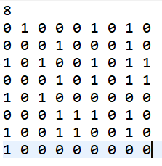

**Astar** (search 33 nodes; path length: 15):

(1,1)(2,1)(2,2)(3,2)(4,2)(5,2)(6,2)(7,2)(7,3)(8,3)(8,4)(8,5)(8,6)(8,7)(8,8)

**UCS** (search 125 nodes; path length: 15):

(1,1)(2,1)(2,2)(3,2)(4,2)(5,2)(6,2)(7,2)(7,3)(8,3)(8,4)(8,5)(8,6)(8,7)(8,8)

**Greedy** (search 16 nodes; path length: 15):

(1,1)(2,1)(2,2)(3,2)(4,2)(5,2)(6,2)(6,3)(7,3)(8,3)(8,4)(8,5)(8,6)(8,7)(8,8)